**Setup WG_VPN client App on Android phone and connect to WG_VPN server [20/10/2020]**

This document will show the detail steps about how to install the WireGuard VPN client on an Android phone/pad and config the VPN client to connect a WG_VPN server. The setup process contents three main steps:

1. Install WireGuard and create a key-pair in WireGuard client.

2. Add the Android client peer information in the WireGuard server’s config file.

3. Config the Android WireGuard client to connect to the server.

**Step 1. Install WireGuard App and create a key-pair in WireGuard client.**

Open the Android phone/pad Google App Play Store and search “WireGuard”, then install the WireGuard VPN client App on the Android phone:

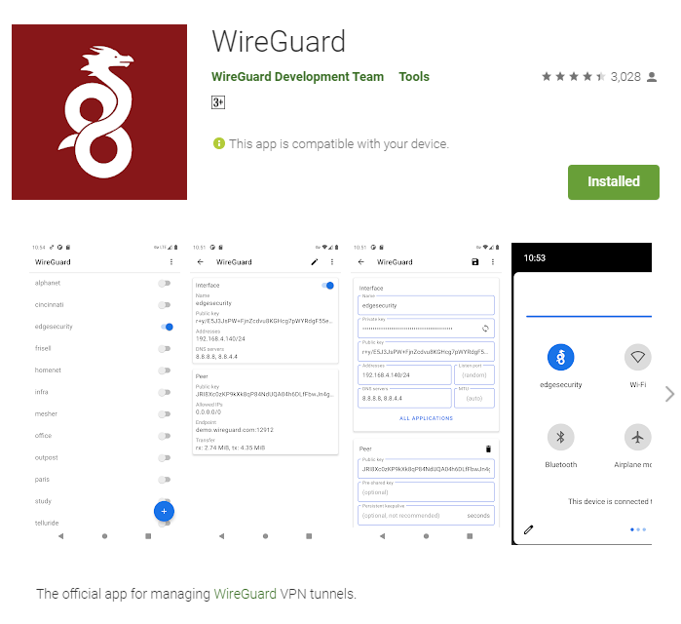

After the installation process finished, open the WireGuard client App:

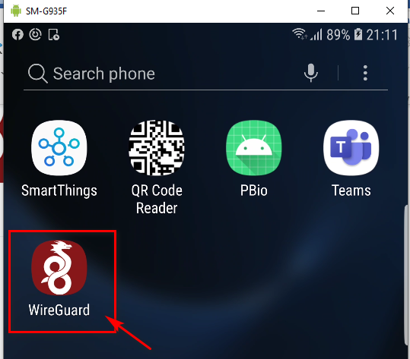

Click the ‘**+**’ button at the bottom right corner and select the “CREATE FORM SCRATCH” to add a new interface:

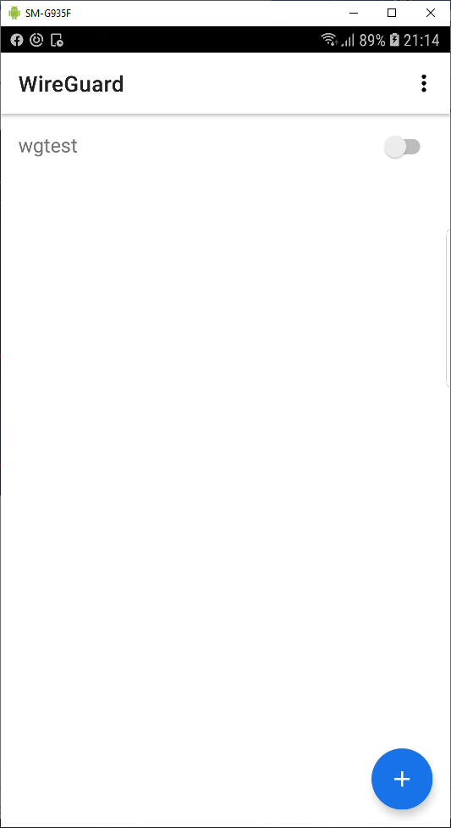 🡺 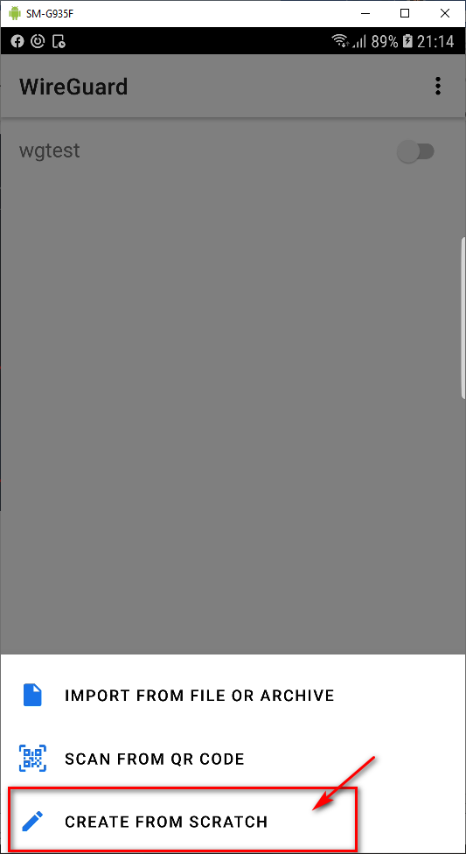

When the setup page popup, type in an interface name and press the “refresh button” once, the encryption key paire will be filled with public key and private key.

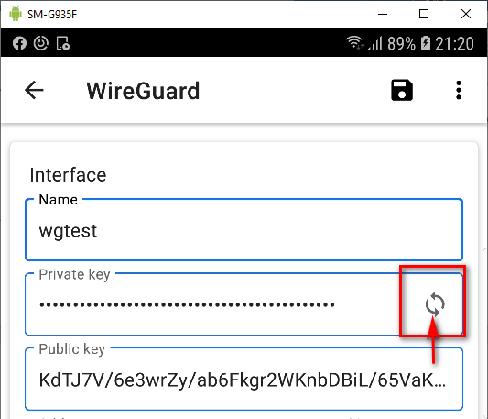

* Record the public key down in a file. In this example record the key string “KdTJ7V/6e3wrZy/ab6Fkgr2WKnbDBiL/65VaKc2F8AE=”

**Step 2. Add the Android client peer information in the server’s config file.**

At the Ubuntu server computer side, stop the WireGuard server by cmd:

**sudo systemctl stop wg-quick@wg0**

Edit the WireGurad config file by cmd:

**sudo vim /etc/wireguard/wg0.conf**

Append below client config line in the file:

**[Peer]**

**## Desktop/client VPN public key ##**

**PublicKey = KdTJ7V/6e3wrZy/ab6Fkgr2WKnbDBiL/65VaKc2F8AE=**

**## client VPN IP address (note the /32 subnet) ##**

**AllowedIPs = 192.168.6.2/32**

* The **PublicKey** is the string we recorded from the Android app in the step 1(as shown below): “KdTJ7V/6e3wrZy/ab6Fkgr2WKnbDBiL/65VaKc2F8AE=”
* The **AllowedIPs** is the IP we want to assign to the VPN client when it has connected.

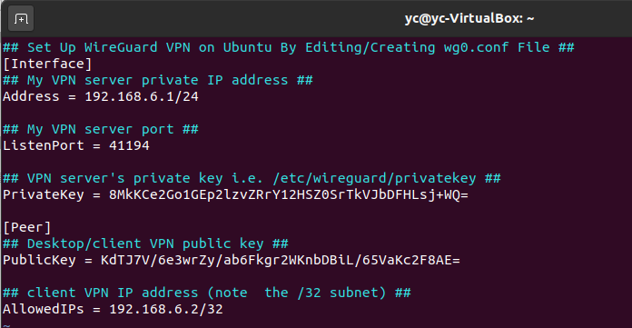

Save the changes and restart the WireGuard server by cmd:

**sudo systemctl start wg-quick@wg0**

**Step 3. Config the Android WireGuard client to connect to the server.**

On the server side get the public key by these two cmds:

**umask 077; wg genkey | tee privatekey | wg pubkey > publickey**

**cat publickey**



Record the server’s public key. In the Android WireGuard App set the interface IP with the same value as the **AllowedIPs** in the step 2.

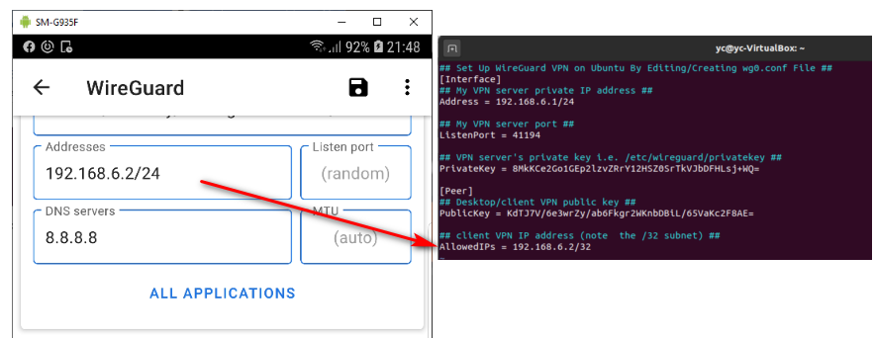

In the Android WireGuard client App side, fill in the Server’s public key, public IP and the port as below. “Allowed IPs” set to “0.0.0.0/32”:

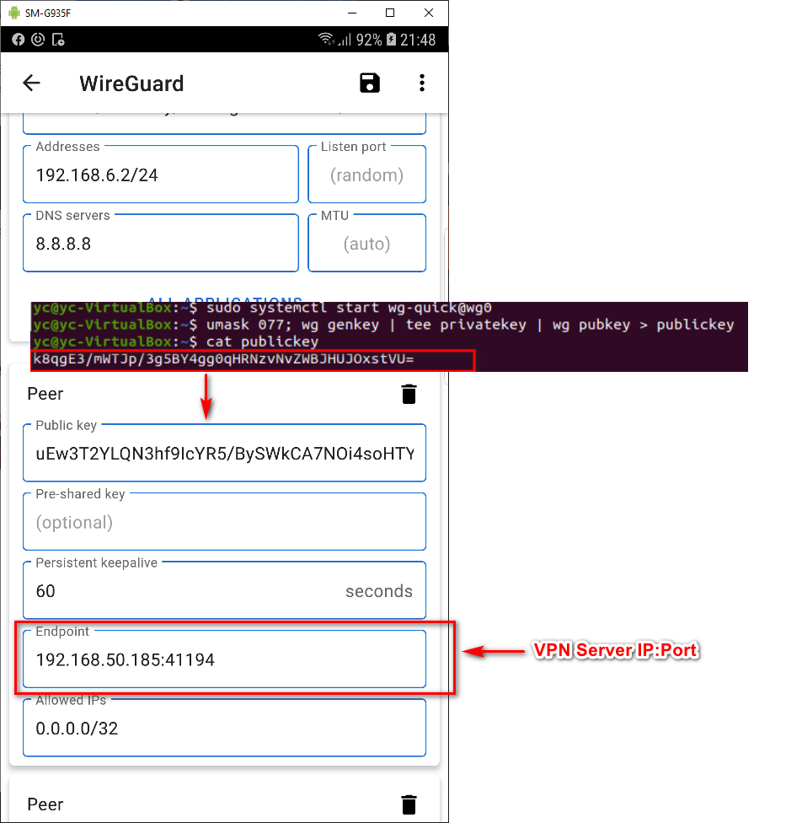

Press the save button to save the changes:

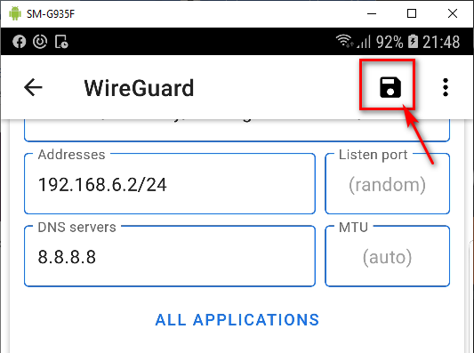

Turn on the connection by press the slider bar:

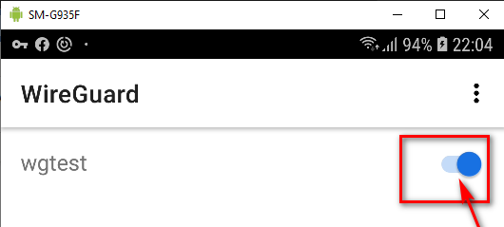

(Optional)Open the Android control centre to check whether the WireGuard VPN client try to connect the server:

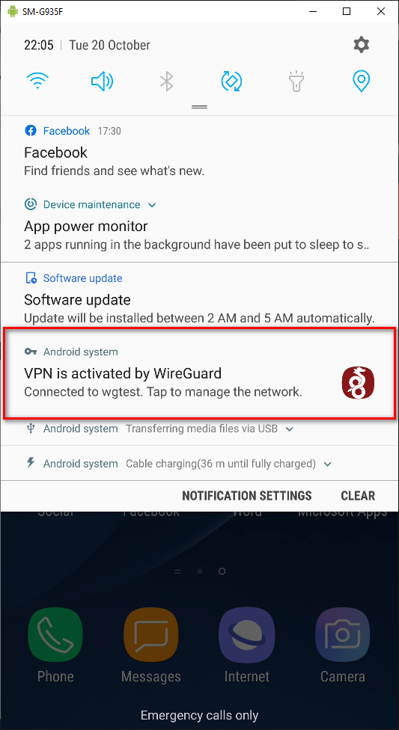

When we see both the data transfer **rx** and **tx** shown, which means the client has connected to the server correctly:

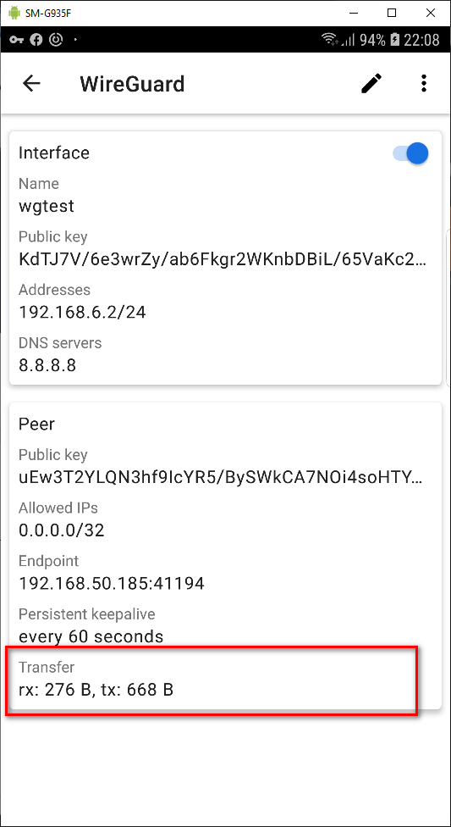

At server side we can also double confirm the connection by cmd:

**sudo wg show wg0**

